EXPLORE ANTIVIRUS DETECCTION 231901005

TECHNIQUES

AIM :

Understand how antivirus software works and what detection techniques are used to bypass malicious file checks.

TASK 2 : ANTIVIRUS SOFTWARE



TASK 3 : ANTIVIRUS FEATURES

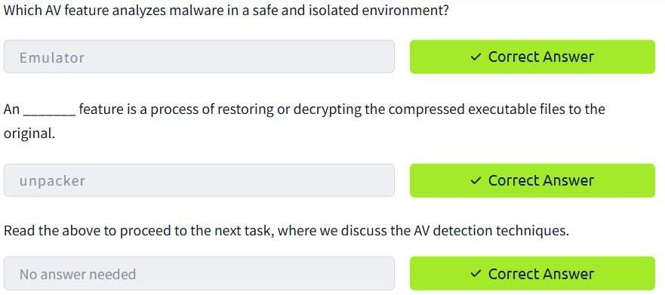

TASK 4 : DEPLOY THE VM



TASK 5 : AV STATIC DETECTION



TASK 6 : OTHER DETECTION TECHNIQUES



TASK 7 : AV TESTING AND FINGERPRINTING

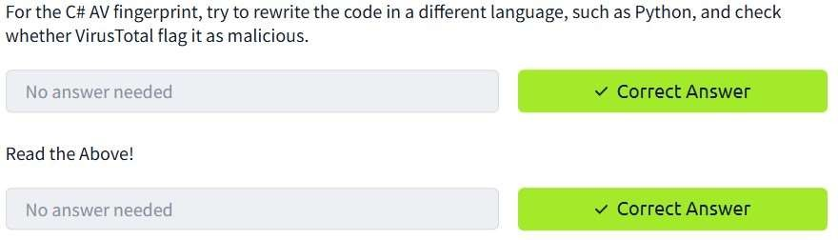

CONCLUSION :

Tor network for anonymous communication task is successfully explored.